USER MANUAL

1. This is the main menu of the **Gopalan Mall**. To generate final bill amount user, need to specify the type of customer in the menu option **Enter customer type =>**. Here ‘**R’ means regular customer and ‘S’ means that customer is Special** and press enter key.

Note: Please don’t enter ‘r’ or ‘s’ as it is case sensitive.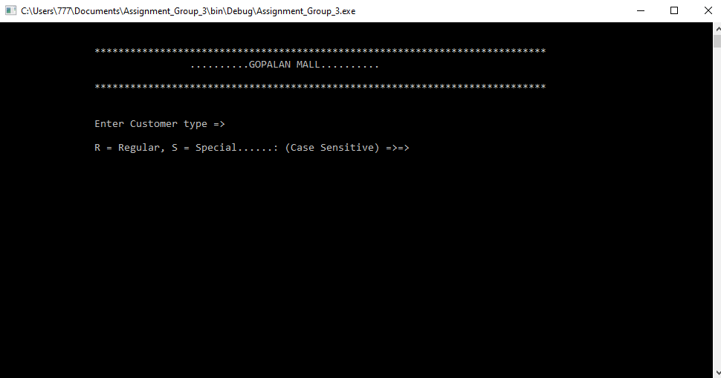

1. After specifying the customer type, user needs to enter the product number and press enter key in the menu option **ENTER PRODUCT NUMBER..........=>=>**. Product number can be combination of both alphabet and numbers. 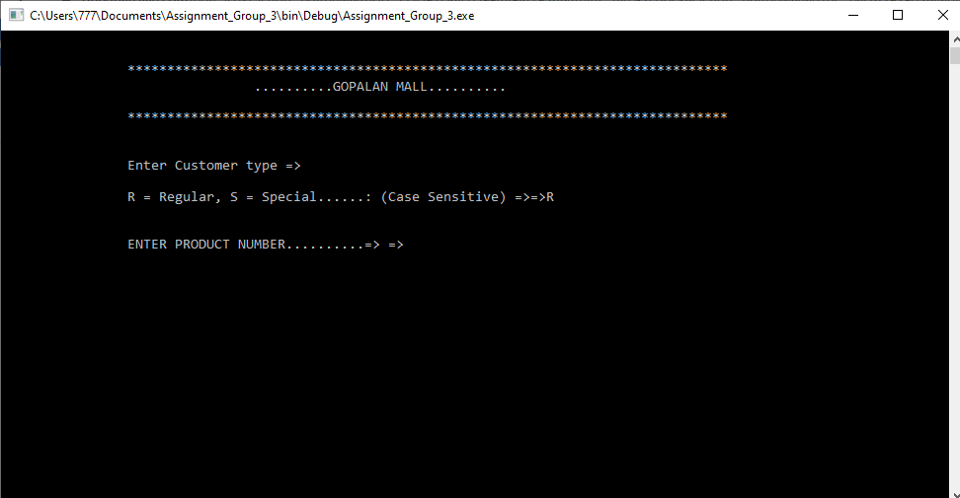
2. After typing the product number, User is required to type the product cost and press enter key in the option **ENTER PRODUCT COST PER UNIT...=>=>**. The product cost should be greater than 10. 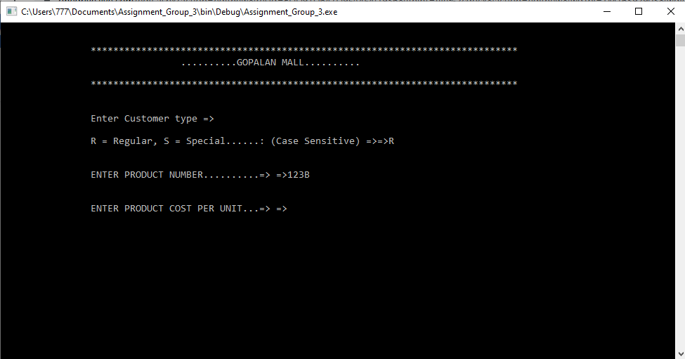
3. In the menu option **ENTER QUANTITY PURCHASED......=>=>**, user is required to enter the quantity that has been purchased and press enter. 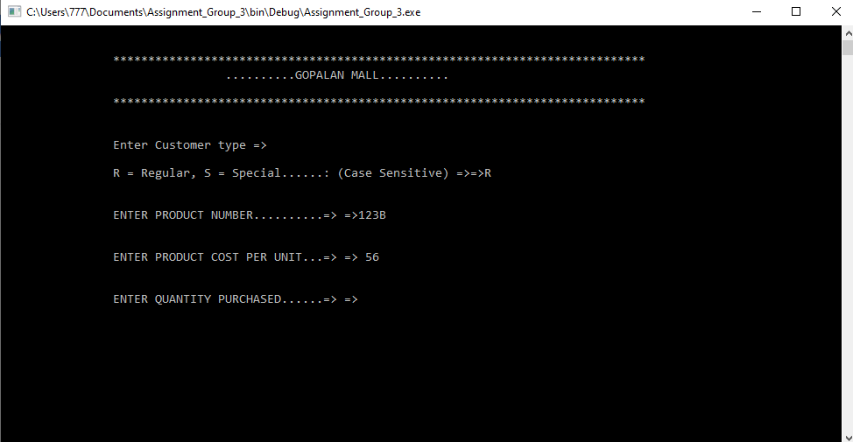
4. Now final bill amount will be generated.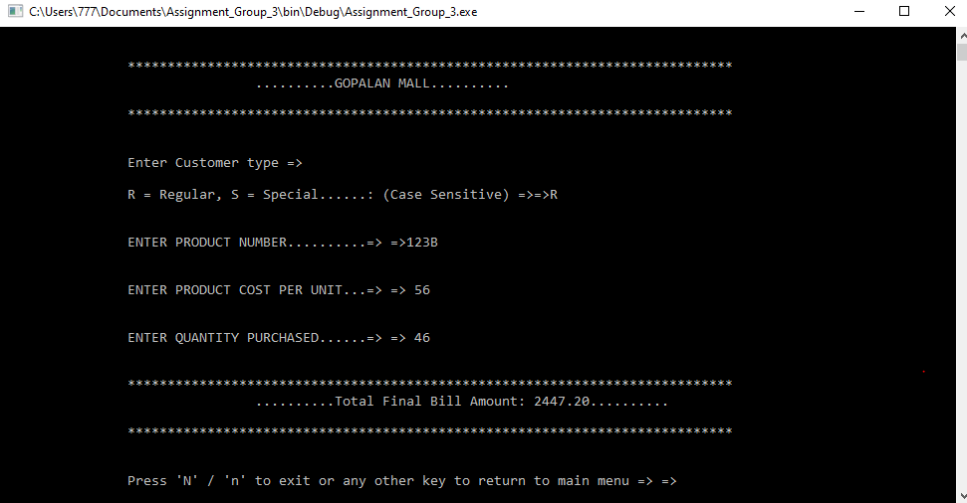
5. If you wish to generate bill for different customer again you can do by typing any other key but not ‘N’ or ‘n’. Application termination allows the user to quit the program after usage. It can be done by typing ‘n’ or ‘N’ and then pressing enter here.